7.2.1 Editors - 3D View - Header tools and Options
Detailed Table of content 1
Introduction 3
Header Tool - Mode Drop-down Box 3
Header Tool - 3D Manipulator Widget 4
Header Tool - Proportional Editing 5
Header Tool - Transform Snapping 6
Header Tool - Viewport Shading 7
Header Tool - Pivot Point 8
Header Tool - Manipulate Center Points 9
Header Tool - Mesh Object - Edit Mode - Mesh Select Mode 9
Header Tool - Mesh Object - Edit Mode - Limit Selection to Visible 10
Header Tool - Mesh Object - Face selection masking for Painting 10
Header Tool - Mesh Object - Vertex selection masking for Painting 11
Header Tool - Particle Edit - Select modes 11
Header Tool - Reset 3D View 12
Header Tool - Align View Buttons 12

Detailed Table of content

7.2.1 Editors - 3D View - Header tools and Options
Detailed Table of content 1
Introduction 3
Header Tool - Mode Drop-down Box 3
Object Mode 3
Edit Mode 3
Sculpt Mode 4
Vertex Paint 4
Weight Paint 4
Texture Paint 4
Edit Strokes 4
Particle Edit 4
Header Tool - 3D Manipulator Widget 4
3D Manipulator 4
Transformation manipulator Translate, Rotate and Scale 4
Last Operator Translate, Rotate and Resize 5
Transform Orientation 5
View 5
Gimbal 5
Normal 5
Local 5
Global 5
Header Tool - Proportional Editing 5
Changing the Proportional influence radius 6
Usage: 6
Header Tool - Transform Snapping 6
Transform Snapping 7
Transform Snapping 7
Snap Element 7
Volume 7
Snapping 7
Edge 7
Vertex 7
Increment 7
Absolute Grid alignment while translating 7
Header Tool - Viewport Shading 7
Rendered 8
Material 8
Texture 8
Solid 8
Wireframe 8
Bounding Box 8
Header Tool - Pivot Point 8
Active Element 8
Median Point 8
Individual Origins 9
3D Cursor 9
Bounding Box Center 9
Header Tool - Manipulate Center Points 9
Header Tool - Mesh Object - Edit Mode - Mesh Select Mode 9
Header Tool - Mesh Object - Edit Mode - Limit Selection to Visible 10
Header Tool - Mesh Object - Face selection masking for Painting 10
Face selection masking for Painting 10
Header Tool - Mesh Object - Vertex selection masking for Painting 11
Vertex selection masking for Painting 11
Header Tool - Particle Edit - Select modes 11
Path 11
Point 11
Tip 12
Header Tool - Reset 3D View 12
Header Tool - Align View Buttons 12
Top, Bottom, etc. 12
View Persp/Ortho 13
Align View to active Camera 13
Set Active Camera 13
Header - Options panels 13

Introduction

The header in the 3D view contains various menus and tools. This chapter here is about the tool, modes and options elements in the header.

Header Tool - Mode Drop-down Box

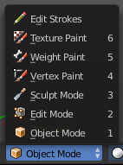
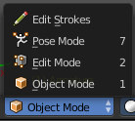
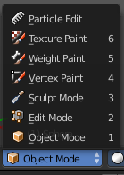
The Mode drop-down box allows you to switch between the different modes.

Modes are object states that allows you to edit and manipulate objects at different levels with different tool sets and goals. The sculpt mode for example allows you to sculpt a mesh object. Edit Mode allows to manipulate the mesh of the object, and so on.

The available modes can differ from object to object. A armature for example has an additional pose mode. And when you work with the grease pencil, then the Edit Strokes mode becomes available.

Object Mode
This mode allows to manipulate objects at Object level. Like move it around, rotate it, etc. This mode is available for all object types.

Edit Mode
The edit mode allows to edit the object. With a mesh object this means that you are able to modify and to change the geometry. With an armature you build your skeleton. And with a text object you can type in text, and choose the font etc.
Not all objects has an edit mode.

Sculpt Mode
Sculpt mode is a mesh object only mode. In this mode you can sculpt the mesh.

Vertex Paint
Vertex Paint is a mesh object only mode. In this mode you can paint vertices with colors.

Weight Paint
Weight Paint is a mesh object only mode. In this mode you can adjust weight painting for an armature for example. But Weight Painted mesh objects can also be used in conjunction with particles.

Texture Paint
Weight Paint is a mesh object only mode. In this mode you can paint at the texture of a mesh directly. This mode requires to have a working UV mapping and a texture at the mesh object.

Edit Strokes
Edit Strokes is a Grease Pencil only mode. It allows to manipulate the curves at a mesh level.

Particle Edit
Particle edit is a Particle System mode only. When you apply a particle system to a mesh object then this mode becomes available. It allows you to manipulate the particle system at a mesh level. You can comb hair particles for example.

Object settings

The object settings just appears when the Tool Settings are hidden. This can be done in the View menu.
The object settings are just visible in Object and Edit Mode.

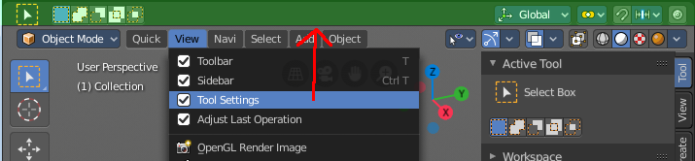

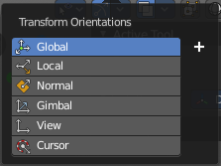
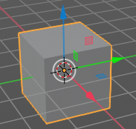
Transform Orientations
You can display Transform Manipulators at your object or selection by activating them in the tool shelf. They allow you to scale, rotate or move objects by grabbing their controls, and moving your mouse in the corresponding axis. The widget can be oriented in different ways by using another method in this dropdown box. The names should be self explaining.

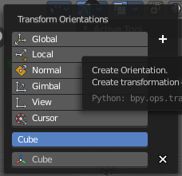
Create Orientation
The create orientation button at the right adds a new orientation from the current mode and view. You can rename it.

This view is scene specific only. It does save and load with the current scene. But you cannot transfer it into another scene. When you create a new scene then this custom orientation is gone.

You can create more than one user orientation.

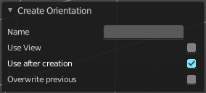
Last Operator Create Orientation
Create Orientation has some settings.

Name
Here you can rename the orientation.

Use View
Use the current view instead of the active object to create the new orientation.

Use after creation
Use this orientation after creation.

Overwrite Previous
Overwrite previous created orientation in case it has the same name.

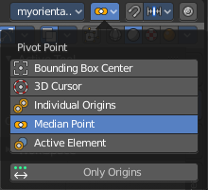
Pivot Point
The Pivot Point is the center of your object or your selection. When you rotate or scale an object, or a group of vertices/edges/faces, you may want to shift the pivot point in 3D space. The names should be self explaining.

Only Origins
When this option is enabled, then the transformation will change the positions of the object’s origins, but will not affect the object itself.

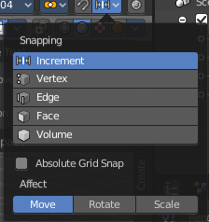
Snapping
Here you can activate snapping.
Snapping can be temporarily activated by holding CTRL key. So no need to turn snapping on and off all the time. This counts for both transform methods. The old method with the W E R hotkeys, and the new method with the widgets.

Snapping Settings
You can snap to various scene elements. Here you can define to which other elements the current active element should snap to. The names should be self explaining. Increment snaps by a grid unit.

Absolute Grid Snap
Absolute Grid alignment while transform. Relative Grid snapping would add to the current position by one unit. Absolute snaps to the nearest ground grid point.

Affect
Here you can adjust what transform methods should be affected by snapping.

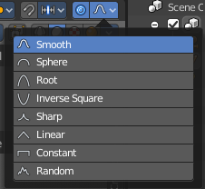
Proportional Editing
Enables proportional editing.
Proportional Editing is a way of transforming selected elements (such as vertices) while having that transformation affect other nearby elements with a falloff. For example, moving a single vertex will move unselected vertices within a given range. And the falloff means that nselected vertices that are closer to the selected vertex will move more than those farther from it.

Settings
The settings appears when you activate Proportional Editing. Here you can choose between different falloff methods for the proportional editing.

Header Tool - 3D Manipulator Widget
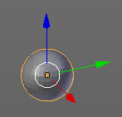
The 3D Manipulator widget tool allows you to enable and to disable a 3D Manipulator widget in the viewport. It is made of several sub elements.
This element exists in most modes. But in Sculpting mode for example the 3D Manipulator is not available.

3D Manipulator
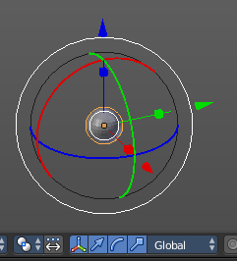
This button activates or deactivates the widget. Have a look at the shortcut here.

Transformation manipulator Translate, Rotate and Scale
Here you can activate or deactivate three different types of widgets. One for Translate, one for Rotate, one for Scale.
You can also activate more than one widget at a time. Hold down shift while clicking at one of the buttons adds to the selection.
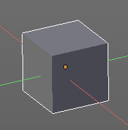
When you use the translate and scale widget, then you can transform in two directions by holding down shift. For example when you use translate widget and pull at the blue handler for upwards in Z direction, then you don't pull upwards, but sidewards in X and Y direction. The green and red line indicates the movement freedom.

When you use the Translate widget and hold down Ctrl, then you move the object with a snapping of one unit.

Last Operator Translate, Rotate and Resize
For the last Operator Translate, Rotate and Resize please have a look in the chapter Navigation Menu. They are identical.

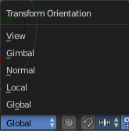
Transform Orientation
Transform Orientation is a drop-down box where you can choose between different orientation methods for the transform operation. The widget points into this direction then.

View
The transform orientation aligns to the current view.

Gimbal
Aligns each axis to the Euler rotation axis as used for input.

Normal
This is of interest for bones for example. Aligns the transformation axis to average normal of the selected elements. Bone Y axis for Pose mode.

Local
Uses the local orientation of the selected elements.

Global
Uses the global orientation for the selected elements.

Header Tool - Proportional Editing

Proportional editing is a way to transform selected elements with some kind of a falloff. So when you for example pull a vertice upwards in Edit mode, the neighbour vertices will also pull upwards, but not so strong. The neighbours gets influenced proportional.
Proportional Editing is not available in all modes.

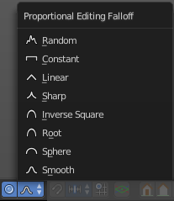
Proportional editing in Object mode is made of two elements. The on off switch. And a drop-down box where you can choose the falloff method.

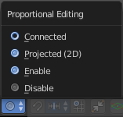
In Edit Mode with a mesh object you just have the on off switch. But here you can choose between three different falloff modes.
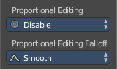
Both settings can be found in the Last Operator panel, when you for example move or scale an object or selection.

Changing the Proportional influence radius
You can change the influence radius for proportional editing with the mouse wheel or the Page up Page down arrows while keeping the mouse button pressed down for translate, rotate or scale. Or at the widget.

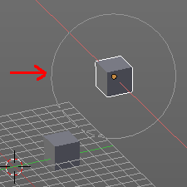
Usage:
Create for example two cubes. Now move one of it around. Enable proportional editing. Choose your favourite falloff method if you want.
When you click at the widget you will see a white circle around the Pivot point. That's the influence radius for the proportional editing.
Now increase the radius for falloff. So that the second cube is in the influence radius. You will see it moving at one point.
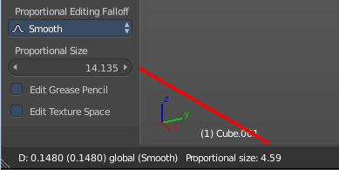
In the last operator Translate there is also a Proportional Size edit box that shows you the size of the radius. Here you can adjust the value too. But note that it will not update the visible influence radius in the 3D view. And when you change the radius in the viewport with the scroll wheel, then it will use the old value, and not the value that you have typed in here. So you better adjust the radius in the viewport. And use this edit box as a visual feedback.

Header Tool - Transform Snapping

Transform Snapping
This element is for snapping while transformation. Not to mix with the snapping tools in the Tools tab in the Tool Shelf. The Transform Snapping tool includes for example grid snapping.
Transform Snapping is not available in all modes.
The Transform Snapping tool is made of three elements.

Transform Snapping
Here you enable or disable snapping.

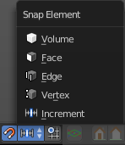
Snap Element
Snap Element is a drop-down box where you can choose between different snapping methods.

Volume
Snapping happens to the volume of another object.

Snapping
Snapping happens to the face of another object.

Edge
Snapping happens to the Edge of another object.

Vertex
Snapping happens to the Edge of another object.

Increment
Snapping happens relative to the ground grid.

Absolute Grid alignment while translating
With this feature on the selection snaps to the grid points. Without this feature it snaps increasing by unit size. When you have a grid snapping of 1, and an element at 0.56, then without absolute grid alignment it will snap at 1.56, 2.56 etc. With absolute grid snapping it will snap at 0, 1, 2 etc.

Header Tool - Viewport Shading

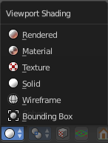
The Viewport shading drop-down box contains the different shading modes for the viewport. It exists in all modes.

Rendered
Displays the content in the viewport like you would have rendered it. This mode is dependant of what render engine you have currently active. And is available for Blender Render and Cycles.

Material
Displays the content in the viewport with all material settings and with OpenGL rendering.

Texture
Displays the content in the viewport textured. You need of course a working UV mapping and a texture at the mesh to see it.

Solid
Displays the content in the viewport with a solid white color.

Wireframe
Displays the content in the viewport as Wireframe.

Bounding Box
Displays the content in the viewport as Bounding box. The mesh content is not displayed.

Header Tool - Pivot Point

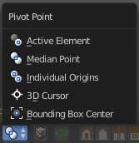
The Pivot Point is the point around which the object manipulation happens. Rotation, mirroring, and so on. Normally this happens around the pivot of the active object. In this menu you can set the pivot point to other locations. Like the position of the 3D cursor.

It exists in all modes.

Active Element
With this setting the manipulation happens relative to the center of the selected active elements. With more than one element is involved, then in Object mode this center gets calculated from the elements pivots. In edit mode the pivot is also the median point.

Median Point
With this setting the manipulation happens relative to the median point of the selected elements. This can be another point than calculating the center of the pivots. The median gets calculated from the geometry, not from the pivot point of the geometry.

Individual Origins
With this setting the manipulation happens relative to the origins of the selected elements. The origin is the little orange dot in every element.

3D Cursor
With this setting the manipulation happens relative to the 3D cursor.

Bounding Box Center
With this setting the manipulation happens relative to the Bounding Box Center.

Header Tool - Manipulate Center Points

This option is of interest when you have more than one object selected. With this option enabled a transformation will change the positions of the object’s origins, but will not affect the object itself.
For example, when you want to scale a group of selected cubes. Without the option enabled the cubes will scale also down when you scale the selection. With this option enabled, the cubes will keep their size. But they will scale closer together. The Pivot points gets scaled.

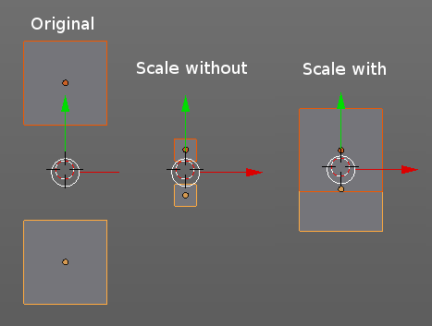

Header Tool - Mesh Object - Edit Mode - Mesh Select Mode

Here you can define what elements you want to select at a mesh object. The display of the mesh changes, dependand of this mesh edit mode.
You can have more than one mode active by holding down Shift and clicking at the buttons to add them to the current selection.
With the default Bforartists keymap the hotkeys X C and V allows you to switch between the modes.
Those hotkeys can't be seen and edited in the header element. But those entries can be seen and edited in the vertices menu, in the Mesh Mode sub menu.

Header Tool - Mesh Object - Edit Mode - Limit Selection to Visible

Limit selection to visible limits the view to what you can see from the front. By default the back geometry shines a bit through.
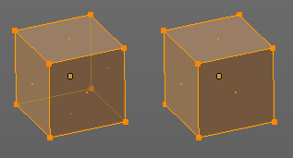

Header Tool - Mesh Object - Face selection masking for Painting

Painting at a Mesh object has two header tools that just belongs to the painting operations. One of it is Face selection masking for Painting. It is visible in Vertex Paint Weight Paint and Texture Paint.

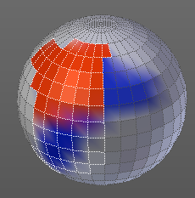
Face selection masking for Painting
When you activate this tool then you reveal a Select menu in the header. And you can select the mesh parts that you want to manipulate.
Note that you may first want to deselect all. By default everything is selected ...
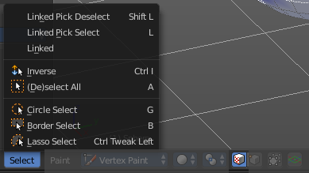

The select menu is explained in the chapter Vertex Painting - Select Menu.

Header Tool - Mesh Object - Vertex selection masking for Painting

Painting at a Mesh object has two header tools that just belongs to the painting operations. One of it is Face selection masking for Painting. It is visible in Vertex Paint and Weight Paint.

Vertex selection masking for Painting
When you activate this tool then you reveal a Select menu in the header. And you can select the mesh parts that you want to manipulate.
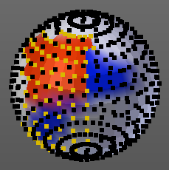
This tool is meant for Weight Painting. And so the mesh displays the vertices too.
Note that you may first want to deselect all. By default everything is selected ...
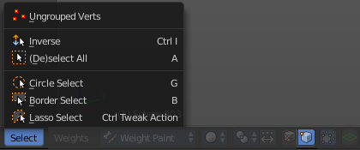

The select menu is explained in the chapter Vertex Painting - Select Menu.

Header Tool - Particle Edit - Select modes

The Select modes allows you to change the display and the editability of the particle vertices.

Path
No keypoints are visible. You can only select or deselect all keypoints at once.

Point
You see all keypoints. And all keypoints are editable

Tip
You can only see and edit the tip keypoints.

Header Tool - Reset 3D View

Reset 3D View is a navigation element. It resets the 3D view to a predefined setting.

It exists in all modes.

Reset 3D View is an add-on, and can be uninstalled when wanted. But note that the functionality is missing then.

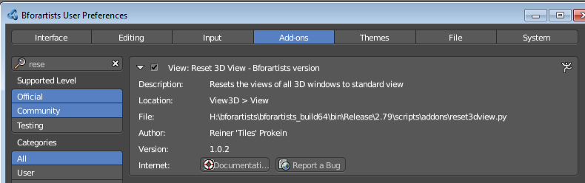

Header Tool - Align View Buttons
The Align View buttons contains some quick navigation elements to navigate in the viewport. You can switch between the different views, switch between orthographic and perspectivic view, switch to camera view and back to viewport view, and set the active camera.
It exists in all modes.
Align View Buttons is an add-on, and can be uninstalled when wanted. But note that the functionality is missing then.
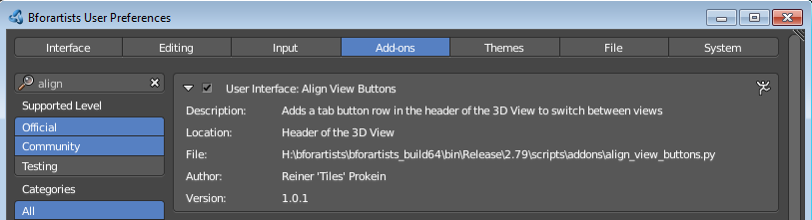

Top, Bottom, etc.
Switches to Top view, Bottom View, etc.

View Persp/Ortho
Toggles between perspectivic and orthographic view. Perspectivic view acts like a real camera with the perspectivic distortions. Orthographic view acts like a mathematical display of an object, without distortions.
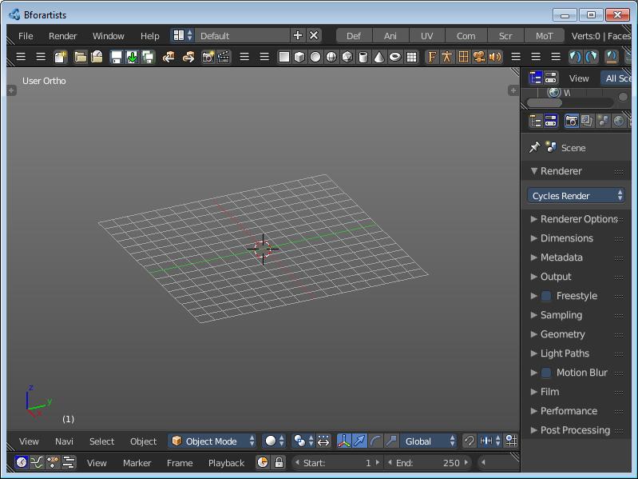
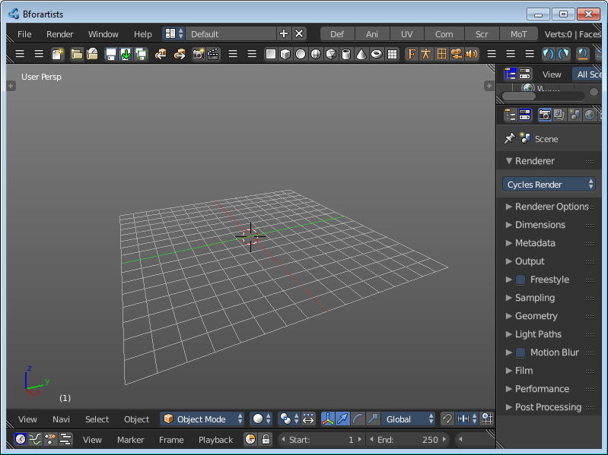

Align View to active Camera
Switches to Camera view and back to Viewport Camera.

Set Active Camera
Sets the currently selected camera as the active camera. The active camera is the camera that gets used for rendering.
You need to have a camera object selected to activate the tool. Unlike the tool in the View menu, this tool here just works for camera objects.

Header - Options panels
